2011 Pardeeville Curling Club Golf Outing Fundraiser
August 6, 2011
New Location - Portage Country Club
Highway 33, Portage, WI
8:30 A.M Shotgun start
$60.00 per person
Includes 18 holes, cart, lunch
Scramble format
All proceeds go to the Pardeeville Curling Club
Please detach, include check made out to Pardeeville Curling Club
Check will not be cashed untill after the event.

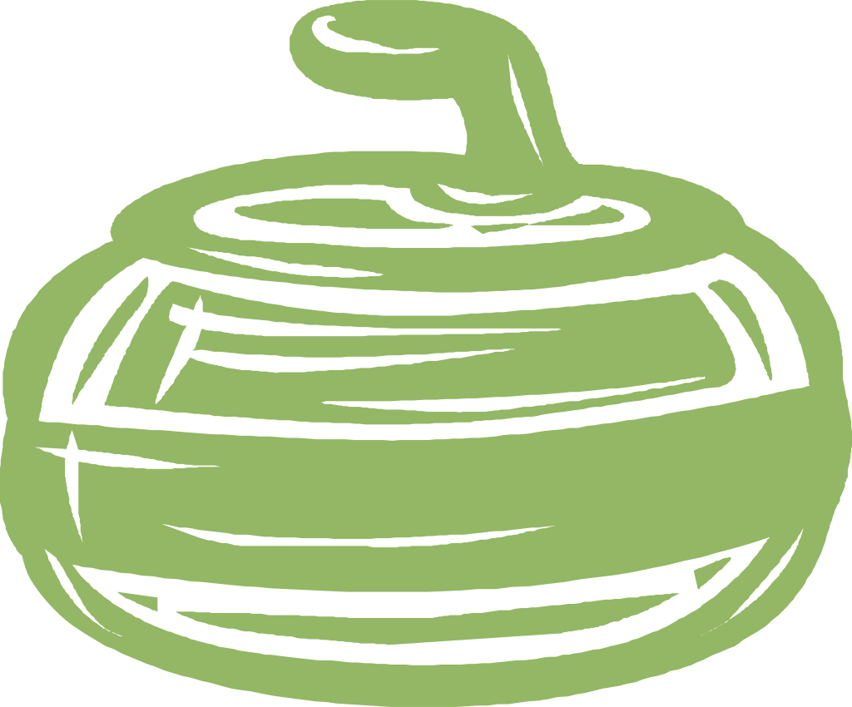
_____________________________________________________________________________________
Mail to:
Debbie McCormick Golfer ________________________________________
W6282 Gorman Road Golfer_________________________________________
Rio, WI. 53960 Golfer _________________________________________
608-212-6047 Golfer ________________________________________
Curling@usa.com Attending the lunch only is $15.00.

