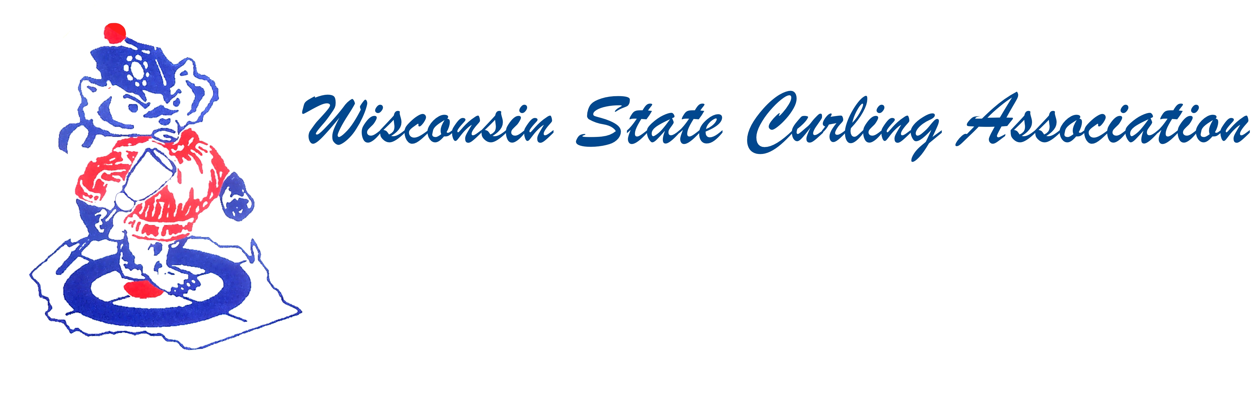
PRESIDENT  Aaron Richards  39 W Madison Ave  Milton, WI 53563  Cell: (608) 290-1993  e-mail: skelecurl@gmail.com  VICE PRESIDENT  Sam Johnson  PO Box 2035  Eau Claire, WI 54702  Phone: (715) 559-1950  e-mail: sam@curlingclub.com  VICE PRES - PLAYDOWNS  Mark Olson  4730 N Catawba Dr  Milton, WI 53563  Home: (608) 580-0058  Cell: (608) 302-2989  e-mail: teachermjo@yahoo.com  SECRETARY  Vietta Kampen  N129 8th Rd  Portage, WI 53901  Home: (608) 587-2320  Cell: (608) 697-6510  e-mail: vkkampen@gmail.com  TREASURER  Greg Dunlop  8124 Chestnut St  Wauwatosa, WI 53213  Home: (414) 778-0341  Cell: (414) 708-5683  e-mail: gdunlop1@hotmail.com  PAST PRESIDENT  Rich Lepping  1634 Sherman Ave  Madison, WI 53704  Home: (608) 663-2473  Cell: (608) 235-1707  e-mail: richardlepping@gmail.com  USCA DIRECTORS (2)  Rich Lepping  See PAST PRESIDENT above  Mark A Hartman  227 Talon Pl  Sun Prairie, WI 53590  Phone: (608) 234-2528  e-mail: mhartma3@amfam.com  WEBSITE  www.wi-curling.org | 46th Wisconsin Junior / 3rd U18 Championship  Wausau Curling Center  Dec. 27-30, 2018  The Wisconsin State Curling Association is pleased to announce the 46th Wisconsin Junior Mens and Womens Championships and third U18 Championship! This year we return to the Wausau Curling Center for the championships. The dates remain in the traditional time slot of Dec. 27-30. The event will be a combined competition comprising the Wisconsin Junior Championship and the U18 Championship, with the events taking place simultaneously.  Eligibility: Wisconsin Junior Championships: Any player who was less than 21 years of age at any time during June 30, 2017 and is a citizen of the United States is eligible to compete for the Wisconsin State Junior Curling Championships. Eligibility for the U18 Competition is governed by rules set forth by the United States Curling Association. For complete information on eligibility for the U18 Competition, please refer to the USCA Curling website (www.usacurl.org). Teams that are not eligible for the U18 Championship (some players ages 18 and over) will compete only for the Wisconsin Badger Junior Championship titles (Bucky Champions patches and trophies). Teams that are eligible for the U18 event will be competing for both titles. It is possible that the same team can win both championships – thereby “going for the deuce”!  Residence Requirement: For the Wisconsin Junior Championship, at least 3 of the team members (4 or 5) must be Wisconsin residents, and members of Wisconsin curling clubs in the WSCA. Separate rules apply for the U18 Championship; please confer with www.usacurl.org.  Coach or Responsible Adult: For the Wisconsin Junior Championships each team must have a representative present who is a Coach or Responsible Adult (at least 21 years of age) in attendance with the team.  Equipment and rule modifications: Equipment rules as specified by the USCA for the U18 Championships will govern for the Wisconsin Junior Championship. We anticipate there will be rule modifications in effect for the National U18 Championship – time out rules and 8 ends games. These rule modifications will be in effect for the Wisconsin Junior Championships as well.  Registration: The U18 registration process is through the USCA website – similar to all other playdown events. The registration deadline on the USCA website is Nov. 21. Entry fee is $300.  For teams registering to play only in the Wisconsin Junior Championship (ages up to 21)– registration is through www.wi-curling.org (Wisconsin State Curling Association website) or via snail mail at: Mark Hartman, 227 Talon PL, Sun Prairie WI 53590. Entry cost is $300.

