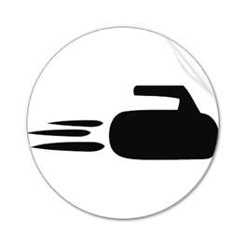
CurlWenatchee

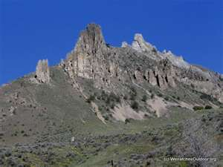
DESERT ROCKS BONSPIEL
An Earlybird Invitational Bonspiel
September 16th,17th, & 18th, 2011

Sponsored by:
THE WENATCHEE CURLING CLUB

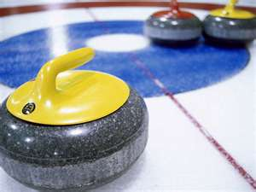

- Each Team should expect to play a minimum of “4” games, but they will be guaranteed “3” games!
- Come see our Central Washington home of scenic fruit & wine country located at the confluence of the Wenatchee & Columbia rivers!
- Cost is $280.00 per Team or $70.00 per Individual Player!
For More Bonspiel Information Please Contact:
Mike McRae, Bonspiel Registrar
mamcrae@frontier.com
Home Phone: 509-664-0651
http://www.wenatcheecurlingclub.com/

