Wenatchee Curling Club’s
Desert Rocks Bonspiel
September 16th, 17th, & 18th, 2011

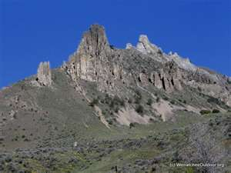
REGISTRATION FORM

“Registration Cost for each Team is $280.00 or $70.00 for an Individual Player!”
- Team Name: ______________________________

- Skip: ____________________________________

- Third: ___________________________________

- Second: _________________________________

- Lead: ___________________________________

Please make checks payable to the “Wenatchee Curling Club” and mail to:
Mike R. McRae, Wenatchee Curling Club Bonspiel Registrar
1021 Idaho Street
Wenatchee WA 98801
mamcrae@frontier.con
Home Phone: 509-664-0651

“Thank You, for making our first invitational bonspiel a huge success!”

