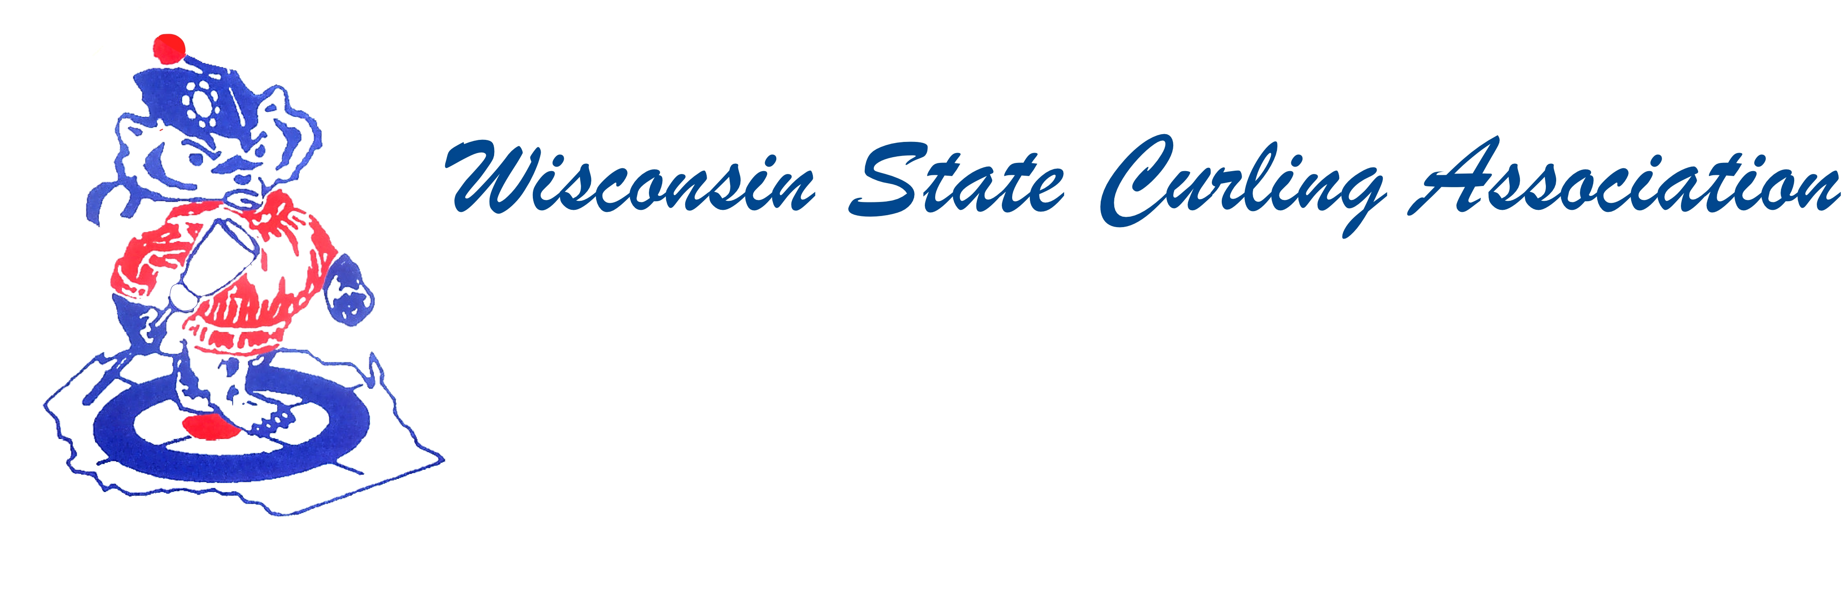
PRESIDENT  Aaron Richards  39 W Madison Ave  Milton, WI 53563  Cell: (608) 290-1993  e-mail: skelecurl@gmail.com  VICE PRESIDENT  Sam Johnson  PO Box 2035  Eau Claire, WI 54702  Phone: (715) 559-1950  e-mail: sam@curlingclub.com  VICE PRES - PLAYDOWNS  Mark Olson  4730 N Catawba Dr  Milton, WI 53563  Home: (608) 580-0058  Cell: (608) 302-2989  e-mail: teachermjo@yahoo.com  SECRETARY  Vietta Kampen  N129 8th Rd  Portage, WI 53901  Home: (608) 587-2320  Cell: (608) 697-6510  e-mail: vkkampen@gmail.com  TREASURER  Greg Dunlop  8124 Chestnut St  Wauwatosa, WI 53213  Home: (414) 778-0341  Cell: (414) 708-5683  e-mail: gdunlop1@hotmail.com  PAST PRESIDENT  Rich Lepping  1634 Sherman Ave  Madison, WI 53704  Home: (608) 663-2473  Cell: (608) 235-1707  e-mail: richl@borderpatrolwi.com  USCA DIRECTORS (2)  Rich Lepping  See PAST PRESIDENT above  Mark A Hartman  227 Talon Pl  Sun Prairie, WI 53590  Phone: (608) 234-2528  e-mail: mhartma3@amfam.com  WEBSITE  www.wi-curling.org | Wisconsin State Curling Association Board of Directors  Saturday, Oct. 1, 2016, 9:00am  Conference Call  Agenda  1. Call to order  2. Roll call  3. Secretary report (last meeting minutes)  4. Treasurer’s report (Dunlop)  5. President remarks (Richards)  6. WSCA service award (Williams)  7. USCA reports (Lepping/Hartman)  8. WCF report (Swandby)  9. Play downs (Olson)  10. Bylaws (Russell)  11. New business  12. Next meeting (date and place)  13. Adjourn

