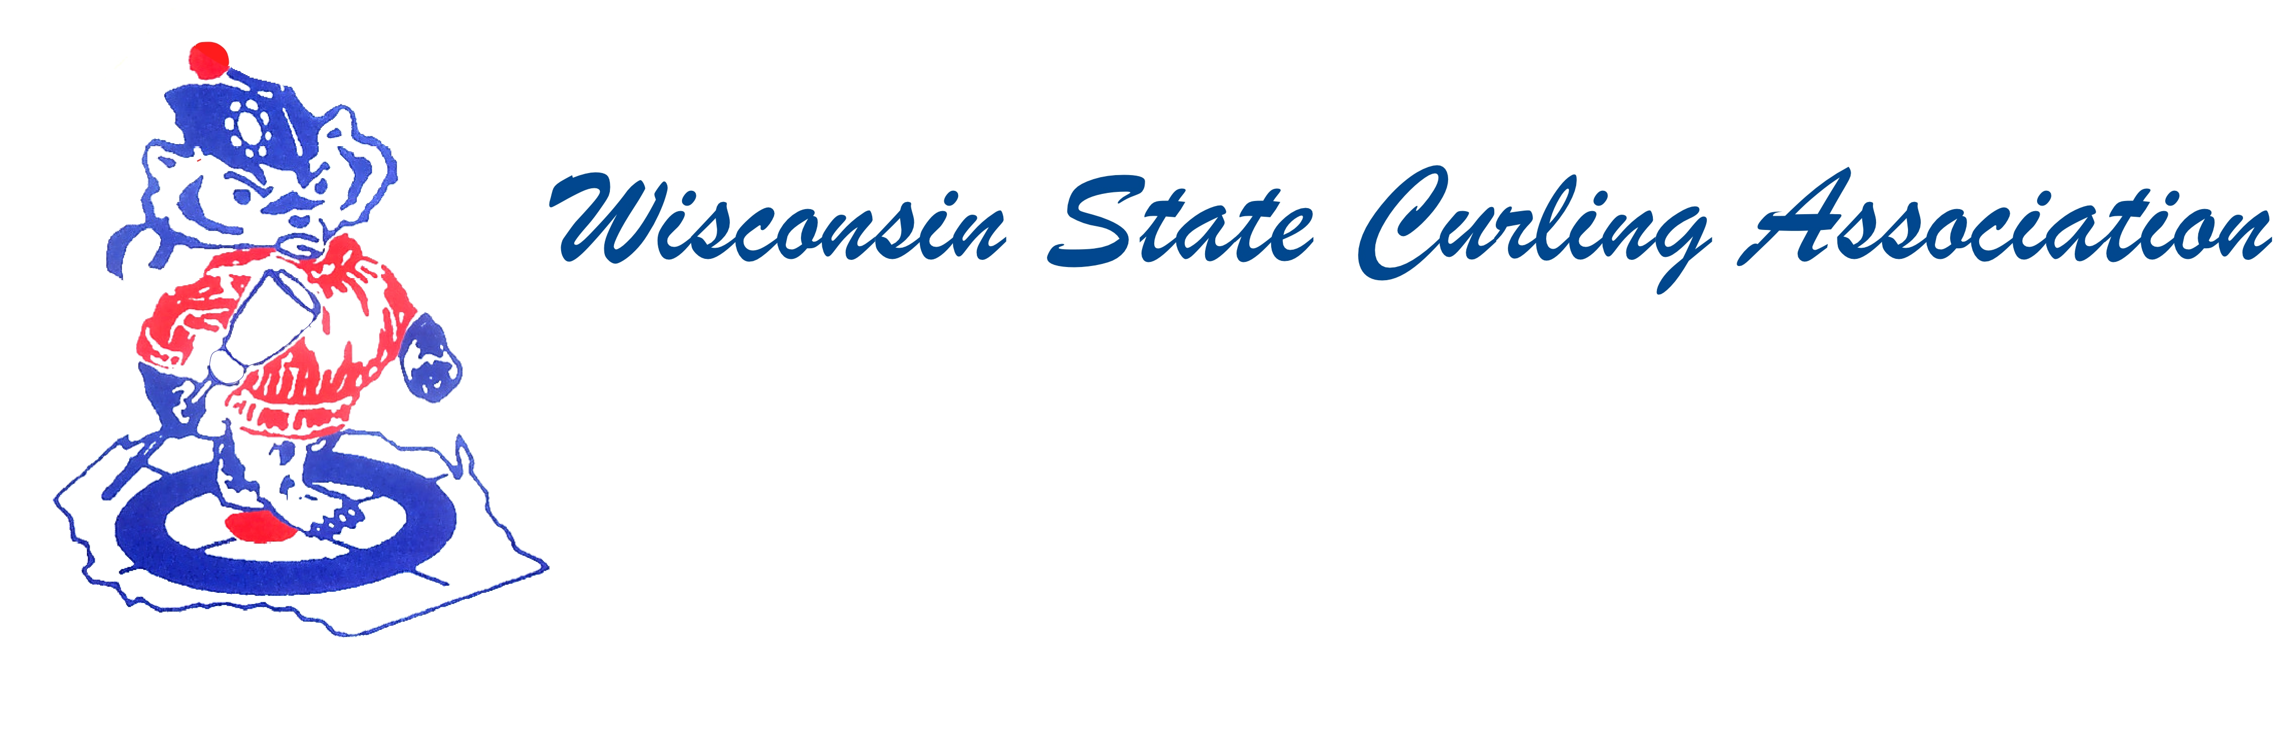
PRESIDENT  Sam Johnson  PO Box 2035  Eau Claire, WI 54702  Phone: (715) 559-1950  e-mail: sam@curlingclub.com  VICE PRESIDENT  Dan Lilla  N20750 Lilla Lane  Trempealeau, WI 54661  Home: (608) 539-3923  Cell: (608) 484-0509  e-mail: lillaroad@aol.com  VICE PRES - PLAYDOWNS  Mark Olson  4730 N Catawba Dr  Milton, WI 53563  Home: (608) 580-0058  Cell: (608) 302-2989  e-mail: teachermjo@yahoo.com  SECRETARY  Vietta Kampen  N129 8th Rd  Portage, WI 53901  Home: (608) 587-2320  Cell: (608) 697-6510  e-mail: vkkampen@gmail.com  TREASURER  Greg Dunlop  8124 Chestnut St  Wauwatosa, WI 53213  Home: (414) 778-0341  Cell: (414) 708-5683  e-mail: gdunlop1@hotmail.com  PAST PRESIDENT  Aaron Richards  39 W Madison Ave  Milton, WI 53563  Cell: (608) 290-1993  e-mail: skelecurl@gmail.com  USCA DIRECTORS (2)  Rich Lepping  1634 Sherman Ave  Madison, WI 53704  Home: (608) 663-2473  Cell: (608) 235-1707  richardlepping@gmail.com  Steve O’Keefe  512 S 52nd Ave  Wausau, WI 54401  Home: (715) 848-1612  Cell: (715) 571-2453  e-mail: okeefes@msn.com | Wisconsin State Curling Association Board of Directors  Saturday, September 29, 2018,  9:30am  Portage Curling Club  107 W Albert Street Portage, WI 53901  Agenda  - Call to Order  - Roll Call (Kampen)  - Approval of Minutes (Kampen)  - Treasurer’s Report (Dunlop)  - USCA Directors’ Report (Lepping, O’Keefe)  - UCF Report (Swandby)  - Committee Reports  - Rules (Maskel)  - Website (Hartman)  - Bylaws (Russell)  - Competition  - Juniors (Hartman)  - Mixed and Men’s and Women’s (Olson)  - Seniors (Hartman)  - High School (Shlimovitz)  - President’s Report (Johnson)  - New Business  - Capitalizing on Olympic success  - 5 shot rule survey  - New Junior’s competition chair  - Other  - Next Meeting date and location  - Adjourn

