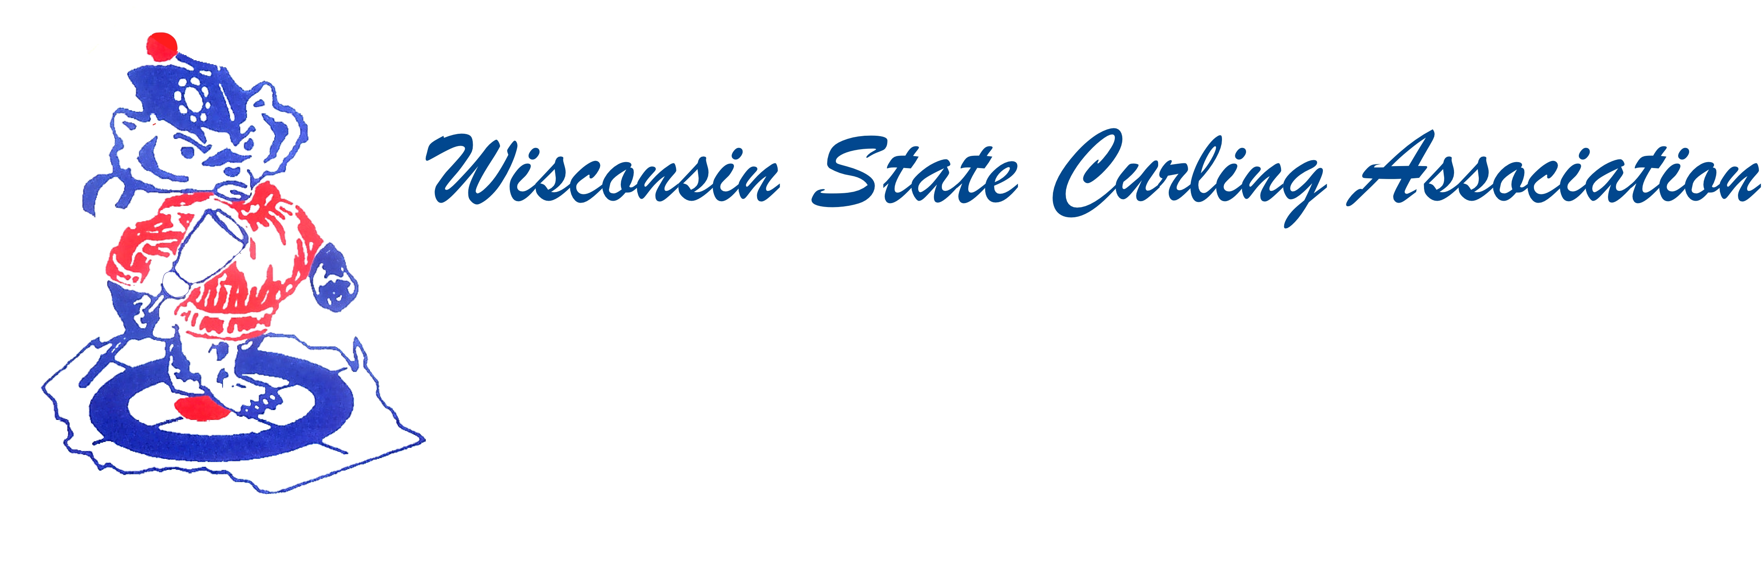
PRESIDENT  Aaron Richards  39 W Madison Ave  Milton, WI 53563  Cell: (608) 290-1993  e-mail: skelecurl@gmail.com  VICE PRESIDENT  Sam Johnson  PO Box 2035  Eau Claire, WI 54702  Phone: (715) 559-1950  e-mail: sam@curlingclub.com  VICE PRES - PLAYDOWNS  Mark Olson  4730 N Catawba Dr  Milton, WI 53563  Home: (608) 580-0058  Cell: (608) 302-2989  e-mail: teachermjo@yahoo.com  SECRETARY  Vietta Kampen  N129 8th Rd  Portage, WI 53901  Home: (608) 587-2320  Cell: (608) 697-6510  e-mail: vkkampen@gmail.com  TREASURER  Greg Dunlop  8124 Chestnut St  Wauwatosa, WI 53213  Home: (414) 778-0341  Cell: (414) 708-5683  e-mail: gdunlop1@hotmail.com  PAST PRESIDENT  Rich Lepping  1634 Sherman Ave  Madison, WI 53704  Home: (608) 663-2473  Cell: (608) 235-1707  e-mail: richl@borderpatrolwi.com  USCA DIRECTORS (2)  Rich Lepping  See PAST PRESIDENT above  Mark A Hartman  227 Talon Pl  Sun Prairie, WI 53590  Phone: (608) 234-2528  e-mail: mhartma3@amfam.com  WEBSITE  www.wi-curling.org | Wisconsin State Curling Association Board of Directors  Saturday, April 30, 2016, 9:30am  Wisconsin Rapids, Tri City Curling Club  Agenda  - Call to Order 10:17  - Motion by Dan Lilla to approve WSCA Minutes from October 10, 2015 as printed, Motion carried.  Motion to Approve Nominating Committee Minutes: March  17 and 31, 2016, Motion carried.  - Treasurer’s Report (see below)  - President’s Report: Rich membership is flat, requests for pins have been denied and sponsorship for junior program ??? see TR  - USCA Director Reports: Rich Lepping – started 2nd term. Good year for championships. Listed the accomplishments. Executive committee made 2 nominations to Hall of Fame Bill Pattenson (USCA requested more information) and Lori Mountford was elected. Curling night in America 1.8 million viewer—funding from WCF USOC NBC USCA. Communication strategy will continue—Rich and Rick Patzke meeting with states and regions, Town Hall calls, Friday afternoon reports (tapas) from Rick Patzke. Moving forward in revenue development. Will have an annual report as a way to communicate. HP staff recommended some changes. Information went out—only received 30 responses. Three changes—eliminate auto entry into the championships, adding the U-18 level, have two regionals for junior playdowns. Men’s and Women’s numbers will remain the about same. Seventy-eight applicants to participated in combines. Mark Swandby—shared the USCA Vision report – commitment to sustained growth through competitive excellence.  - WCF: Mark Swandby—Discussion about Broom/Sweeping Techniques: Gave the background, plans for a Town hall meeting, WCF addressing the issue over the summer.  - Break  - Committee Reports:  - Rules: Swandby—No report  - Website: Hartman (see report below)  - Bylaws: Russell—No report  - Competition:  - Juniors: Hartman (see report below)  - Mixed and Men’s and Women’s: Richards— Two teams played down in mixed. There were 12 men’s teams and 3 women’s teams. The most in recent years. Poynette will host Mixed and Eau Claire will host the Men’s and Women’s playdowns.
  - Seniors: Jack Baker (see report below)
  - High School: Chris View shared the results of the HS Championships
J. WSCA Service Award: O’Neill—Bernie Dushek was the first recipient. Award was presented in Arlington. Rich and Beth Lepping donated the plaque.
K. New Business
A. Transgender Policy—Rich discussed the policy that would be presented at
USCA meeting.
B. Stick Policy—Rich discussed the purposed recommendation to allow the
use of a delivery stick in events not leading to World championships. Not
supported by show of hands.
C. Dar Curtis Award—reminded 501(c)(3) clubs to apply for this grant.
D. Kim Nawyn presented information on the Business of Curling Symposium
in Milwaukee June 4-5.
E. Kim presented information on the Athlete Development Model.
•New Kid’s Curl program for 6-9 year olds is being developed. Looking
for 20 clubs to pilot it.
•Level 2 Ice Making Course in Wisconsin Rapids this summer
•Level 2 Instructor has a new program
• Member’s Assembly in Arizona in October
•Officiating classes—WCF will be voting on changes, new rule book
which will necessitate changes to the USCA rule book and courses.
F. Scot Tour—Ladies going to Scotland in November 2016, Scot Men
coming to US from Jan. 15-Feb 5. Mark Swandby is coordinating things.
L. Election of New Officers: O’Neill
A. The slate of nominations was presented: President—Aaron Richards:,
VP— Sam Johnson; VP Playdowns – Mark Olson; Secretary—Vietta
Kampen; Treasurer—Greg Dunlop. Nominations were requested from the
floor. Mark Hartman nominated Dan Lilla for VP. There being no other
nominations, motion by David Russell to close nominations and elect the
nominated slate, with the exception of the contested VP position.
Unanimous vote of approval.
B. Motion by Mike Fonger to close nominations as to the VP position.
Second by Lance Bagstad. Both Sam Johnson and Dan Lilla addressed the
Board. Ballots were cast. Sam was elected VP.
C. Motion by David Russell that the current officers and the most recent two
past presidents be elected as the Executive Committee. Second by Dan
Lilla. Unanimous vote of approval.
D. Aaron Richards presented Rich Lepping with his Past President’s pin.
M. Fall Date and Location: Eau Claire, October 1st, 10:00.
N. Adjourn: Motion by Jim O’Neill to close the meeting at 1:20.

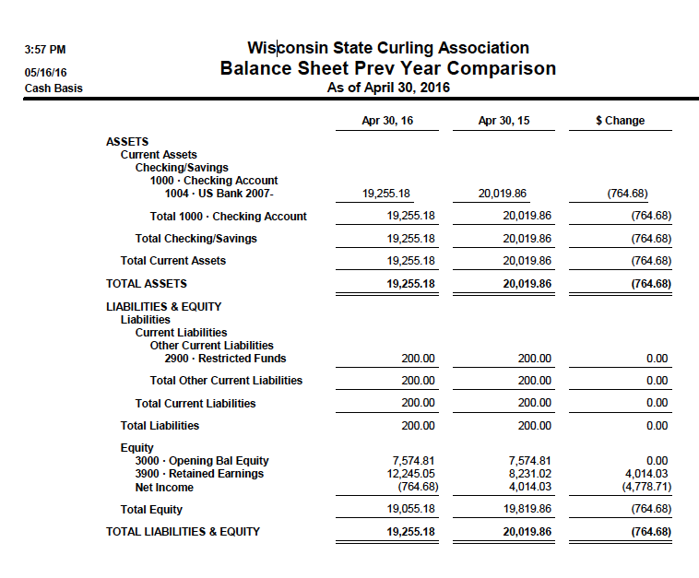
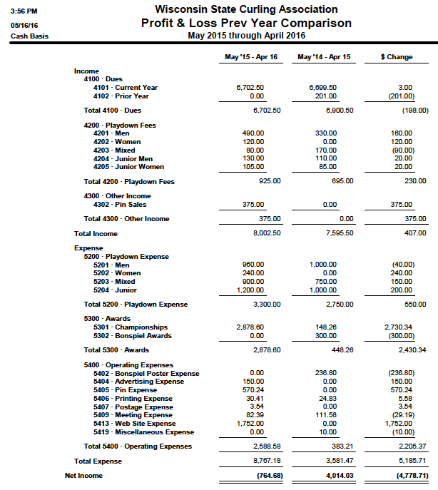
WEBSITE REPORT
April 30, 2016
WWW.WI-CURLING.ORG

This completes the first season after the major upgrade to the website that took place during the summer of 2015. Along with bringing the design of the website up-to-date, I believe we have a more attractive site, and one that is easier to navigate. Data input has been simplified which I appreciate from a volunteer standpoint. Probably the biggest cosmetic change is the improvement in the looks of the bonspiel calendar. Each year we enter over 100 events during the season, mostly Wisconsin curling events but also complete championship information for all events of interest to Wisconsin curlers.
A new feature for the website this year is a page for WSCA Service Award. The first winner is Bernie Dushek from Arlington. We’ve dressed up the webpage with some photos from the celebration banquet, so I suggest everyone to check it out.
Speaking of checking out the website, we are generating a great deal more interest in the site from viewers using the contact form. Most of them are looking for information on how they can get started curling or how they can set up a Team Building activity with a learn-to-curl event. I try to answer these items as promptly as possible – however sometimes they get lost in my mountain of mail, especially when I am on vacation!
I have been trying to add photos to the webpages whenever I can. We have some nice photos from the Wisconsin Junior Championship from Portage CC, and photos of the High School Champion teams, both of them from Kettle Moraine this year. I encourage all state championship teams to send me photos.
As usual during the summer, we will load all of the new directory information: mainly the new club officers and the bonspiel calendar. I do not need to contact the clubs as the USCA shares this information with us. Please use the contact form if anyone has ideas for website content.
Mark Hartman

JUNIOR PLAYDOWNS
April 30, 2016

The Portage Curling Club left its mark on Junior Curling this year in Wisconsin, as it hosted the Wisconsin Junior Championships on Dec. 27-30. 6 boys teams and 5 girls teams competed in the event which is a slight increase in numbers over last year, and the highest numbers we’ve had in the last several years. The Portage ice was home ice for both of the Champions, both of which were extended to two tie-breakers to successfully defend Wisconsin’s borders against teams led by non-Wisconsin players that took the second places. On the girls side, Anne Marie Dubberstein defeated Sidney Schroeder Houghton, MI) by 10-7 in the championship game. On the boys side, Rob Shlimovitz skipped his team to the state championship in an extra end 7-6 win, against Matt Carlson, from Mapleton, MN.
My thanks to Vietta Kampen, who served as the local chair, and her entire team of volunteers from the Portage club. Next season will see significant changes in the Junior Championships, as the USCA is going to be instituting an Eastern and Western regional based national championship qualification procedure for the national championship leading to the world junior championship, with the Mississippi River defining the borders of the regions. In addition, a new 17 and under junior championship is going to take place, which will be similar in nature to the club team championships for adults.

Mark Hartman

Wisconsin State Seniors Report Spring 2016
It has been a successful year of curling for the State of Wisconsin Seniors.

The Wisconsin State Senior Bonspiel was held at the Milwaukee Curling Club in January with
32 teams entered. 24 Senior and 8 Masters. The Neidhart rink of Madison won the Seniors and
the Qualie rink of Arlington won the Masters. Listed below are the rinks and members.
Seniors Masters
Madison CC Arlington CC
Ken Neidhart Dave Qualie
Paul Ryan Cliff Erstad
Kevin Teschendorf Bill Monteufel
Rob Wixon Gordon Dunn
Everyone enjoyed the new facility and new rocks. Only positive comments were heard.
Looking forward to Madison in 2017.

In February the Wauwatosa and Kettle Moraine Curling Clubs hosted the United States Senior
Bonspiel. 64 teams from across the USA participated. Next year it will be hosted by Columbia
County which involves 5 clubs. Wisconsin continues to be a leader in Senior Mens Bonspiels.

WISCA continues to be a stronghold in South Central/Eastern Wisconsin. Many club teams
travel to other clubs and meet to curl against one another. Congratulations to the Milwaukee 3
team for winning the championship.

It is with a sad heart I have to report a founding member of this group Sam MacNeil recently
passed away. He was an active force in curling on the state and national levels. He was
involved with getting the World Curling Bonspiel in Milwaukee in 1989 I had the pleasure of
knowing Sam and curling with and against him. He is in heaven now starting a new curling club
with No Free Guards.

Finally I have decided it is time to have someone else take over my duties as Wisconsin State
Senior Director. It is always nice to get “new blood” and ideas how to keep improving for
Wisconsin Seniors. I have taken this from mailing envelopes to the age of computer with email
addresses for all participants. We have a current email list updated each year. I think this helps
in getting the necessary teams for this bonspiel. Most clubs now have bonspiel applications on
their website and can download directly to the participating club. Mr. Mark Hartman has agreed
to take over this responsibility and comes with high recommendations. Please continue to
support Mark as you have supported me.

Sincerely,
Jack Baker
Wisconsin State Senior Director

The following report did not make it into the previous minutes. They have been added.
Wisconsin State Seniors Report Fall 2015
The state seniors are looking forward to another fine year of curling.
In addition to our State Senior Bonspiel to be held at the Milwaukee Curling club, Wisconsin will
be hosting the United States Senior Bonspiel to be held at Wauwatosa/Kettle Moraine curling
clubs. What a great state to curl in!
Many Seniors have not had the chance to curl at the new Milwaukee Curling Club. They just
purchased new stones and are all set to go.
In addition in the South Central/Eastern part of the state WISCA is going strong.
Many senior curlers are only curling in senior events as many are getting older and the body
cannot take it like we used too. Good thing for senior events and bonspiels.
The date for the Wisconsin State Senior Bonspiel at Milwaukee Curling Club is January 22-24.
Jack Baker
Wisconsin State Senior Director

