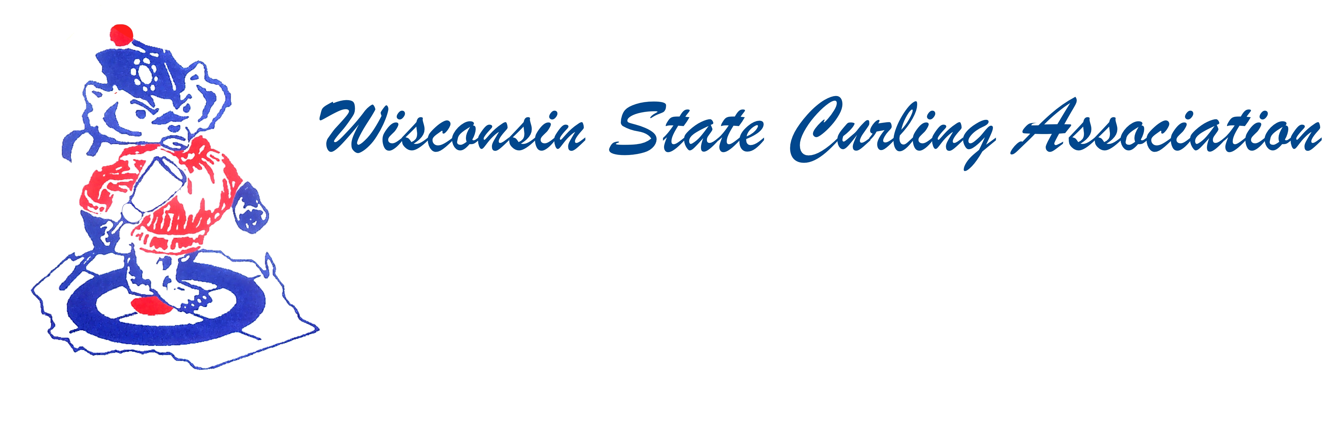
PRESIDENT  Aaron Richards  39 W Madison Ave  Milton, WI 53563  Cell: (608) 290-1993  e-mail: skelecurl@gmail.com  VICE PRESIDENT  Sam Johnson  PO Box 2035  Eau Claire, WI 54702  Phone: (715) 559-1950  e-mail: sam@curlingclub.com  VICE PRES - PLAYDOWNS  Mark Olson  4730 N Catawba Dr  Milton, WI 53563  Home: (608) 580-0058  Cell: (608) 302-2989  e-mail: teachermjo@yahoo.com  SECRETARY  Vietta Kampen  N129 8th Rd  Portage, WI 53901  Home: (608) 587-2320  Cell: (608) 697-6510  e-mail: vkkampen@gmail.com  TREASURER  Greg Dunlop  8124 Chestnut St  Wauwatosa, WI 53213  Home: (414) 778-0341  Cell: (414) 708-5683  e-mail: gdunlop1@hotmail.com  PAST PRESIDENT  Rich Lepping  1634 Sherman Ave  Madison, WI 53704  Home: (608) 663-2473  Cell: (608) 235-1707  e-mail: richardlepping@gmail.com  USCA DIRECTORS (2)  Rich Lepping  See PAST PRESIDENT above  Mark A Hartman  227 Talon Pl  Sun Prairie, WI 53590  Phone: (608) 234-2528  e-mail: mhartma3@amfam.com  WEBSITE  www.wi-curling.org | Wisconsin State Curling Association Executive Committee  Date: Jan 22, 2017  Place: Conference Call  Members Present: Rich Lepping, Aaron Richards, Greg Dunlop, Vietta Kampen  Absent: Sam Johnson, Mike Dry, Mark Olson  Rich moved to approve the reinstatement of the Alpine Curling Club. Greg seconded the motion. Discussion: Alpine overwhelmingly voted to rejoin both the USCA and the WSCA. Upon approval Alpine will be granted provisional membership into the USCA and will be eligible for the new dues program which phases the dues in over two years. Their membership is down from 120 to 65. Passed: 4-0. Vietta will contact Kim Nawyn to let her know the decision.  Rich noted that he is up for re-election as WSCA Director to the USCA. He is willing to run again. The Nominating Committee should put forth a nomination at the Spring Meeting. A list of responsibilities is on the WSCA Website.  Aaron moved to reimburse Superior and Blackhawk for the Club Championship Trophy. Rich seconded the motion. Discussion: It is a traveling trophy for the Men’s Club Championships which leads to Nationals. Passed: 4-0.  USCA Meeting is April 22, 2017. WSCA moved to April 29, 2017, at 9:30am in Portage, WI.  Aaron adjourned the meeting at 7:30pm.

