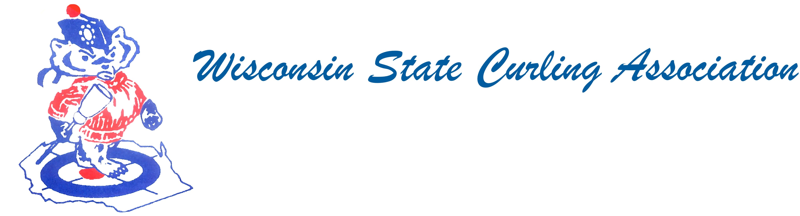

PRESIDENT
Aaron Richards
39 W Madison Ave Milton, WI 53563
Cell: (608) 290-1993
e-mail: skelecurl@gmail.com

VICE PRESIDENT
Sam Johnson PO Box 2035
Eau Claire, WI 54702 Phone: (715) 559-1950
e-mail: sam@curlingclub.com

VICE PRES - PLAYDOWNS
Mark Olson
4730 N Catawba Dr Milton, WI 53563
Home: (608) 580-0058
Cell: (608) 302-2989
e-mail: teachermjo@yahoo.com

SECRETARY
Vietta Kampen N129 8th Rd Portage, WI 53901
Home: (608) 587-2320
Cell: (608) 697-6510
e-mail: vkkampen@gmail.com

TREASURER
Greg Dunlop 8124 Chestnut St
Wauwatosa, WI 53213
Home: (414) 778-0341
Cell: (414) 708-5683
e-mail: gdunlop1@hotmail.com

PAST PRESIDENT
Rich Lepping
1634 Sherman Ave
Madison, WI 53704
Home: (608) 663-2473
Cell: (608) 235-1707
e-mail: richardlepping@gmail.com

USCA DIRECTORS (2)
Rich Lepping
See PAST PRESIDENT above

Mark A Hartman 227 Talon Pl
Sun Prairie, WI 53590 Phone: (608) 234-2528
e-mail: mhartma3@amfam.com

Wisconsin State Curling Association Executive Committee
Date: March 13, 2018 Place: Conference Call Time: 5:00 pm

Members Present: Aaron Richards, Sam Johnson, Mark Olson, Vietta Kampen, Greg Dunlop, Rich Lepping

Visitor: Mark Hartman for beginning of the call

Discussions centered around the upcoming spring meeting.

USCA Directors: Mark Hartman’s term is up in 2018, Rich Lepping’s terms is up in 2019. We need to find people interested in these positions. Also discussed was offering a stipend or percentage to the directors. Rich said that at least six regions offered compensation.

WSCA Officers: The Vice President’s position is up. Need to find a person who is interested in taking on this role. Vietta Kampen and Greg Dunlop are willing to stay on in their current positions.

Also discussed was a possible increase in dues. It has been $1.50/curler for over 20 years. With the compensation for officials and host clubs, and possibly for the Directors, this issue should be addressed at the upcoming meeting.

Mark Olson brought up how the teams are selected for Club Championships with regard to the number of teams playing down in a region and the number of teams that go on to play at the National level. A letter will be sent to the USCA to facilitate this discussion at the upcoming committee/Board meetings. Also discussed was a rotating schedule for playdowns based on recent interest to host and the number of sheets per club.

Agenda items were discussed for the Spring Meeting. Greg Dunlop moved to adjourn at 6:13 pm

WEBSITE
www.wi-curling.org

