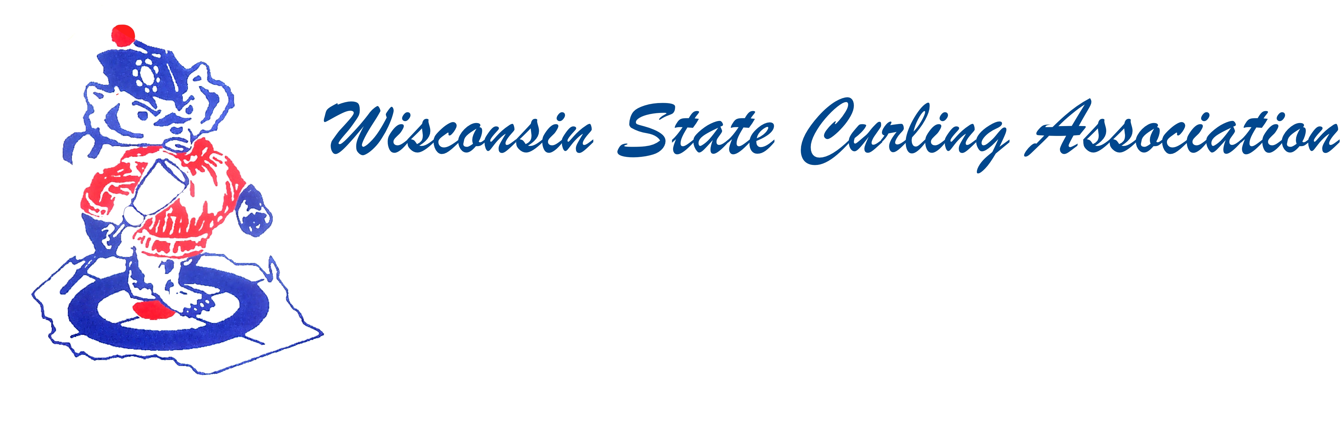
PRESIDENT  Sam Johnson  PO Box 2035  Eau Claire, WI 54702  Phone: (715) 559-1950  e-mail: sam@curlingclub.com  VICE PRESIDENT  Dan Lilla  N20750 Lilla Lane  Trempealeau, WI 54661  Home: (608) 539-3923  Cell: (608) 484-0509  e-mail: lillaroad@aol.com  VICE PRES - PLAYDOWNS  Mark Olson  4730 N Catawba Dr  Milton, WI 53563  Home: (608) 580-0058  Cell: (608) 302-2989  e-mail: teachermjo@yahoo.com  SECRETARY  Vietta Kampen  N129 8th Rd  Portage, WI 53901  Home: (608) 587-2320  Cell: (608) 697-6510  e-mail: vkkampen@gmail.com  TREASURER  Greg Dunlop  8124 Chestnut St  Wauwatosa, WI 53213  Home: (414) 778-0341  Cell: (414) 708-5683  e-mail: gdunlop1@hotmail.com  PAST PRESIDENT  Aaron Richards  39 W Madison Ave  Milton, WI 53563  Cell: (608) 290-1993  e-mail: skelecurl@gmail.com  USCA DIRECTORS (2)  Terri Gleason  Phone: ‭(608) 831-7365‬  e-mail: mntgleason@gmail.com  Garret Perry  Phone: gqperry@gmail.com  e-mail: gqperry@gmail.com | Wisconsin State Curling Association Board of Directors  Saturday, Oct. 5, 2019, 9:00am  Conference Call  Phone: 1-866-469-3239 access code: 801 804 801  Video: https://jamf.webex.com/meet/sam  Agenda  - Call to Order  - Roll Call (Kampen)  - Approval of Minutes (Kampen)  - Treasurer’s Report (Dunlop)  - President remarks (Johnson)  - USCA Directors’ Report (Gleason, Perry)  - WCF Report (Swandby)  - Committee Reports  - Rules (Maskel)  - Website (Hartman)  - Bylaws (Russell)  - Competition  - Juniors (Hartman)  - Mixed and Men’s and Women’s (Olson)  - Seniors (Hartman)  - High School (Shlimovitz)  - New Business  - Election of USCA Directors  - Election of Juniors Competition Chair  - Next Meeting date and location  - Adjourn

