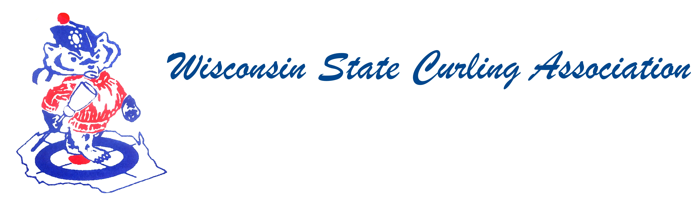
PRESIDENT  Sam Johnson  PO Box 2035  Eau Claire, WI 54702  Phone: (715) 559-1950  e-mail: sam@curlingclub.com  VICE PRESIDENT  Dan Lilla  N20750 Lilla Lane  Trempealeau, WI 54661  Home: (608) 539-3923  Cell: (608) 484-0509  e-mail: lillaroad@aol.com  VICE PRES - PLAYDOWNS  Mark Olson  4730 N Catawba Dr  Milton, WI 53563  Home: (608) 580-0058  Cell: (608) 302-2989  e-mail: teachermjo@yahoo.com  SECRETARY  Vietta Kampen  N129 8th Rd  Portage, WI 53901  Home: (608) 587-2320  Cell: (608) 697-6510  e-mail: vkkampen@gmail.com  TREASURER  Greg Dunlop  8124 Chestnut St  Wauwatosa, WI 53213  Home: (414) 778-0341  Cell: (414) 708-5683  e-mail: gdunlop1@hotmail.com  PAST PRESIDENT  Aaron Richards  39 W Madison Ave  Milton, WI 53563  Cell: (608) 290-1993  e-mail: skelecurl@gmail.com  USCA DIRECTORS (2)  Rich Lepping  1634 Sherman Ave  Madison, WI 53704  Home: (608) 663-2473  Cell: (608) 235-1707  richardlepping@gmail.com  Steve O’Keefe  512 S 52nd Ave  Wausau, WI 54401  Home: (715) 848-1612  Cell: (715) 571-2453  e-mail: okeefes@msn.com | Wisconsin State Curling Association Board of Directors  Saturday, April 27, 2019, 9:30am  Portage Curling Club  107 W Albert Street Portage, WI 53901  Minutes  - Sam Johnson called the meeting to order at 10:55am  - Roll Call (Kampen)  - Present: Centerville, Eau Claire, Kettle Moraine, Madison, Pardeeville, Portage, Stevens Point, Tri-City, Waukesha, Wausau, Wauwatosa  - Absent: Alpine, Appleton, Arlington, Blackhawk, Clinton, Green Bay, La Crosse, Loch Wissota, Lodi, Marshfield, Medford, Milwaukee, Poynette, Racine, Rice Lake, Superior, Waupaca  - Approval of WSCA Board of Directors Minutes: Fall 2018 (Kampen) Jim Shlimovitz moved to approve the minutes, Second – Amanda Seichter. Approved  - Treasurer’s Report (Dunlop) Greg shared his report during the Members Meeting. He will submit a final report to Vietta when they are finalized.  - USCA Directors’ Report (Lepping, O’Keefe)  - Rich Lepping: There is a USCA Board meeting on May 10th in Colorado. In January the board voted to reduce the size of the board with a three-year phase in. Rich gave the back ground for the change. Ratification will be at the board meeting at the Members Assembly which will be held in Milwaukee in October. There were concerns with the region going from two directors to one. USCA fees will go up $3.00. The USCA Board’s main focus has been and will continue to be holding the CEO accountable. There are concerns with the HP program and staff, marketing after the Olympics, and decision making for the Slam. Kim Nawyn is now working for the UW. There have been 40 applicants for the position. The HP program was praised for the bronze in Mixed Doubles. Currently, the HP program is in the selection process and should be finalized in two weeks.  - Steven O’Keefe: Steven will be serving on the Audit/Finance Committee and the Growth and Development Committee. There is an ad-hoc committee set-up to find volunteers to act as middlemen for people who want to start up a club or clubs looking to grow their junior program, rather than swamping the USCA office with questions.  - WCF Report (Swandby) No report – be sure to look for information in the Curling News. Lepping shared that Mark’s term is expiring but that Mark would continue to serve on the Rules Committee.  - Committee Reports  - Rules (Maskel) No report  - Website (Hartman) No report  - Bylaws (Russell) No report  - Competition  - Juniors (Hartman) See the report below  - Mixed and Men’s and Women’s (Olson) See the report below  - Seniors (Hartman) See the report below  - High School (Shlimovitz) Jim shared that there were 53 teams this year at the Tietge HS bonspiel in Wausau. Nineteen schools were represented. At the state HS championship, 15 school districts were represented. New this year was a boy’s team from LaCrosse Logan. Wausau West won the boy’s division and Portage won the girl’s division. This is Jim’s last year on the HS board. There was a discussion about the need for more coaches at the HS level, but also for teams competing in the U18 and Junior Nationals. It’s been awhile since a coaching clinic has been held.  - President’s Report (Johnson) See the minutes from the members meeting  - WSCA service Award (Lilla) This year’s award goes to Mark Hartman. There is one plaque left, so the board will need to take over ordering and paying for them. Dan Lilla and Rich will get together on that. Vietta will take care of engraving and presenting this year’s award.  - New Business:  - USCA Hall of Fame Nomination: Superior nominated Tim Somerville for his accomplishments as a curler. The Executive Committee met and approved this nomination. Tom Godar moved to bring the nomination forward to the USCA, second – Doug Anderson. Motion carried with Rich Lepping, Steven O’Keefe and Doug Anderson abstaining.  - USCA Director Options: The Executive Committee shared their recommendation that the WSCA does not fill the second director’s position at this meeting. As of May’s USCA Board meeting, Rich’s term will be done; this can reviewed in the fall based on the outcome of the May meeting, and before the change in the structure of the board is ratified at the Members Assembly. After some discussion, Dan Lilla moved to nominate Rich Lepping to continue to serve on the USCA Board, second – Tom Godar. Motion carried with Rich and Steven abstaining. Greg Dunlop moved that WSCA vote in favor of the reduction of the USCA Board of Directors, second – Tom Godar. Motion carried.  - Vietta shared figures that Mark Olson collected regarding the regional fees collected for playdowns. It was noted that Wisconsin is at or near the bottom for each event, but at this point the financial information does not warrant an increase in these fees.  - Rich brought forth some information about two individuals who have been banned from curling due to background checks done during the Safe Sport compliance. This information is sent to the presidents of the clubs and is available on the USCA website. Safe Sport is free for all members of the clubs and needs to be implemented for all people working with junior curlers.  - Election of USCA Director (As Needed) See 11)b.  - Special Election of New Officers (VP of Playdowns) Mark Olson will finish off his term and Mike Elwing will shadow him for the year.  - Set Fall Date and Location: Discussion was held to have the WSCA Fall meeting at the Members Meeting in Milwaukee in October. However, there were some conflicts. So Time/Date/Location will be determined at a later date.  - Adjourn: Amanda moved to adjourn at 12:44pm  2019 - Wisconsin Junior and Senior Championships  Chair: Mark Hartman  Juniors:  The Wisconsin 2019 Junior Championships took place at the Wausau Curling Club on Dec. 27-30, 2018. My thanks to Wausau Curling Club and local chair, Jim Wending for agreeing to take on the championship again this year! Winning the double round robin on the Girls’ side was the Samantha Jones team from Portage along with teammates Abigail Marquardt, Elizabeth Vorpahl and Anna Armstrong representing Portage along with other clubs. The Champion Boys Team was the Wesley Wending rink from Wausau. They emerged with two wins in a double tie-breaker scenario to win the U-18 Championship. In a separate competition they played flawlessly against 5 other teams to win the Boys Badger Championship as well. Curling with Wendling were John Wilkerson, Jackson Armstrong and Christopher Kirsch. With their victories in the Wisconsin Championships, Wendling and Jones also qualified for the U-18 National Championships in Chaska, MN.  Seniors:  The Wisconsin Senior Men’s Championship was hosted by the Medford Curling Club on January 18-20. Many participants enjoyed a nap in front of the large fireplace, the most unique feature of the Medford Curling Club. We have a new champion this year as Ken Neidhart was denied in his attempt to win his third in a row. Winning the first event was the Tom Rave rink from Wauwatosa. Curling with Tom were Carl Deutsch at lead, Harold Paul at second and Mike Willeman at vice. They defeated Rice Lake teams in the quarters and also in the first event final. Next year the event will be hosted by the Kettle Moraine Curling Club.  My Final Report for Juniors and Seniors  This will be my final report for the Junior and Senior Championships. I’ve enjoyed overseeing these events for the last several years (more years for juniors than for seniors), and I wish to thank the many volunteers who helped me over the years in managing these events. It has been a joy for me to manage these events but I am also looking forward to celebrating the holidays with my family and friends , for more than just one day each year. Certainly I am willing to help advise the folks who take over these duties, if they wish my input, and if they don’t that’s fine too! I am still willing to serve as the Website Coordinator. In the future I am looking forward to seeing more of you while competing on the ice, and less from behind the glass!  2018-19 PLAYDOWN RESULTS  Chair: Mark Olson  Waupaca CC hosted this year’s men’s & women’s club play downs December 13-16.  There were 11 men’s teams and two women’s teams.  The men’s division was won be the Dan Schally rink of Madison and the women’s division was won by the Sydney Schmus rink also of Madison. We also sent a second women’s team Cindy Ryhner, as a fill spot.  Sydney went on to win the national championship gold medal and Dan’s rink won the national silver.  A great showing from Wisconsin this year as it is the first medal in the men’s division since 2012. The women on the other hand finished 1 & 2 last year!  Wisconsin had four teams play down for the state mixed title at Stevens Point CC February 1-3, 2019.  The Ben Richardson rink won and represented Wisconsin at Nationals. Unfortunately Ben and his team did not medal.

