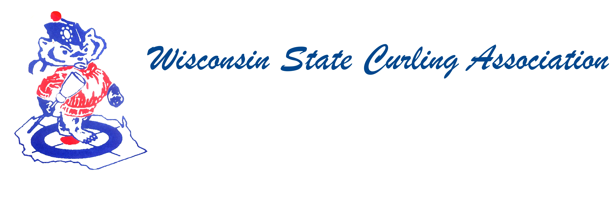
PRESIDENT  Aaron Richards  39 W Madison Ave  Milton, WI 53563  Cell: (608) 290-1993  e-mail: skelecurl@gmail.com  VICE PRESIDENT  Sam Johnson  PO Box 2035  Eau Claire, WI 54702  Phone: (715) 559-1950  e-mail: sam@curlingclub.com  VICE PRES - PLAYDOWNS  Mark Olson  4730 N Catawba Dr  Milton, WI 53563  Home: (608) 580-0058  Cell: (608) 302-2989  e-mail: teachermjo@yahoo.com  SECRETARY  Vietta Kampen  N129 8th Rd  Portage, WI 53901  Home: (608) 587-2320  Cell: (608) 697-6510  e-mail: vkkampen@gmail.com  TREASURER  Greg Dunlop  8124 Chestnut St  Wauwatosa, WI 53213  Home: (414) 778-0341  Cell: (414) 708-5683  e-mail: gdunlop1@hotmail.com  PAST PRESIDENT  Rich Lepping  1634 Sherman Ave  Madison, WI 53704  Home: (608) 663-2473  Cell: (608) 235-1707  e-mail: richl@borderpatrolwi.com  USCA DIRECTORS (2)  Rich Lepping  See PAST PRESIDENT above  Mark A Hartman  227 Talon Pl  Sun Prairie, WI 53590  Phone: (608) 234-2528  e-mail: mhartma3@amfam.com  WEBSITE  www.wi-curling.org | Wisconsin State Curling Association Board of Directors  Minutes 2016 Fall Meeting of the USCA  Date: Saturday, Oct. 1, 2016, 9:00am  Place: Conference Call  Call to order: 9:02  Roll Call – Present: Blackhawk, Centerville, Eau Claire, Green Bay, Kettle Moraine, Madison, Milwaukee, Wauwatosa, Portage, Poynette, Racine, Rice Lake, Superior, Wausau  Absent: Appleton, Arlington, Clintonville, La Crosse, Loch Wissota, Lodi,  Marshfield, Medford, Pardeeville, Stevens Point, Tri-City, Waukesha, Waupaca  Also in Attendance: Rich Lepping, Mark Swandby, Jeff Koch, Joel Dietzen  Approval of Minutes: Motion by Mike Dry, seconded by Mike Fonger to approve Minutes from the 2016 Spring Meeting as printed. Unanimous vote of approval.  Treasurer’s Report: Greg Dunlop stated that his computer crashed. Balance in the account is $19,123. Motion by Dan Lilla, seconded by Jeff Koch to approve Treasurer’s Report. Unanimous vote of approval.  President’s Report: (Aaron Richards) Discussed the reason for the change to the conference call. Asked directors to send him feedback about the conference call.  WSCA Service Award: (Sam Williams) There were no nominations for this year. The steering committee is looking for nominations for the 2016-2017 curling season. Anybody who would like to be on the committee should contact Sam who is the chair. He is looking for five other members for the committee. He will send out notification By February. Vote will be at the Spring Meeting.  USCA Reports: (Lepping/Hartman)  Rich Lepping shared that Alpine would be voting at their next board meeting to get back into the WSCA and the USCA. Rich welcomed Aaron as new president, mentioned Vietta is going on the Scot Tour in November. USCA Member’s Assembly will be in Phoenix. One hundred people will be attending. Rich shared that the HP teams are playing in bonspiels and staffing of HP coaches is complete. Revenue development is still struggling.  Membership is up slightly with most of the growth generated by Arena Clubs.  There will be a modified dues structure for new clubs. The Transgender Policy passed. A proposed stick rule change was put back to the committee for clarification. There will be an orientation program for new USCA Directors.  Mark Hartman shared that the Omaha Curling Club will be the host for the 2018 Olympic Team Trials, Nov. 12-19, 2017. Jan. 27-29, 2017 Brazil will challenge the US Men’s and Women’s teams for a spot at Worlds. Teams for the World Championships can now be any team who wins Nationals and is in the top 25 in points.  Slightly  WCF Report: (Swandby) Mark shared the highlights from the WCF meeting in Stockholm, Sweden including the changes in sweeping, fabric and number of devices for any competition leading to Worlds. There are also penalties in place for non-compliance, and the rules committee can have an emergency meeting during any of the World Championships. Other rule changes include: can start competition with three players, double touch before the hogline is not a foul, travel time whether or not a coach goes out on the ice, there will be a minimum number of ends even if a team has been mathematically eliminated, and stones can be reconditioned during an event. Mixed Doubles will use seeding after the 1st round. The American Zone has been extended. There was also discussion concerning the wheelchair qualification system, U18 and U23, and mixed doubles will have possibly more rule changes. The Scot Tour is coming to the US. They will start in Chicago on January 14, 2017.  Play downs: Mark Olson reported that Eau Claire would host Men’s and Women’s Club Championships Dec. 15-18. Sam Johnson is the chair. Poynette will host Mixed from Feb. 3-5. U18 and Wisconsin Junior Playdowns will be held in Portage, Dec. 16-18.  Bylaws: No Report  New business:  Irv Mossberger had a traveling trophy made for the Men’s Club Championships. His team along with Ryan Spielman are donating it, but would like the WSCA to consider reimbursing them for the cost.  Next meeting: Tentative date April 22, 2017, 9:30 am in Portage, WI.  Is it possible to have a conference call with a speaker phone set up for those who can’t make it to the meeting.  Adjourn: Motion by Greg Dunlop and second by Mike Fonger to Adjourn at 10:29am.

