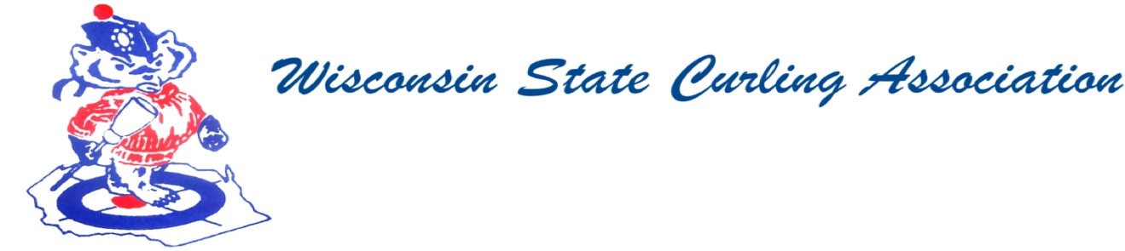
PRESIDENT  Sam Johnson  (715) 559-1950  sam@curlingclub.com  VICE PRESIDENT  Dan Lilla  (608) 484-0509  lillaroad@aol.com  VICE PRES - PLAYDOWNS  Mark Olson  Cell: (608) 302-2989  teachermjo@yahoo.com  SECRETARY  Vietta Kampen  (608) 697-6510  vkkampen@gmail.com  TREASURER  Greg Dunlop  (414) 708-5683  gdunlop1@hotmail.com  PAST PRESIDENT  Aaron Richards  (608) 290-1993  skelecurl@gmail.com  USCA DIRECTORS (2)  Terri Gleason  (608) 575-0457  mntgleason@gmail.com  Garret Perry  (608) 358-6344  gqperry@gmail.com | Wisconsin State Curling Association Members Meeting  Saturday, July 18, 2020 at 8:00 AM  Zoom Meeting  Minutes  1) Sam Johnson called the meeting to order at 10:20 AM.  2) Roll Call (Kampen)  a) Present: Arlington, Blackhawk, Centerville, Clintonville, Eau Claire, Green Bay, Kettle Moraine, La Crosse, Madison, Medford, Milwaukee, Pardeeville, Portage, Poynette, Racine, Rice Lake, Stevens Point, Superior, Waukesha, Wausau, Wauwatosa  b) Absent: Alpine, Appleton, Loch Wissota, Lodi, Marshfield, Tri-City, Waupaca  c) Guests: Garret Perry, Terri Gleason, Rich Lepping, Mark Swandby, Dan Lilla, Clint Schroeder, Dwayne Jacobson, Mark Olson, Wendy, Bill Rhyme, Jennifer Severin  3) Approval of WSCA Membership Meeting Minutes: Spring 2019 Tom Godar moved to approve, 2nd – Amanda Seichter. Approved  4) Treasurer’s Report: Sam Johnson highlighted some of the numbers  5) President’s Report (Johnson) – no report Garret Perry thanked Sam for his service to the organization.  6) Club Reports – See below  7) New Business  a) What can USA Curling do to help clubs? They are reaching out to each of the clubs. If your club hasn’t received a call, reach out to Steven O’Keefe. If you have any idea what programs or information your club would like to see addressed, they are open to suggestions and new ideas.  b) Create a grant fund to expand curling in WI (similar to Dar Curtis  Award) This idea will be addressed at the next Executive Committee meeting. If you are interested in being on a committee contact Dan Lilla.  c) Club members need to be kept informed of the ongoing situation. Make use of Zoom meetings to reach out to your membership.  8) Vietta moved to adjourn at 10:55, 2nd – Chris Horak.  CLUB REPORTS  Centerville Curling 2019-2020 Season  The Centerville Curling Club’s 2019-2020 Season had our membership staying about the same as last season and Bonspiels doing better than the previous season. We host more bonspiels than many clubs, we sponsor a Senior Open, Senior Men’s, Women’s, Mixed. Men’s and an Open Fun Bonspiel which is for any combination of Teams such as Adults, Children, New Curlers, Students and people who have never curled before. This Bonspiel runs from late Friday Afternoon until; late Saturday Evening and makes a genuinely nice profit. We also hosted a USCA Junior Challenge Round Event. Covid-19 shortened our season by about ten days and forced us to cancel our Senior Men’s Bonspiel, also.  The one new thing this past season was the purchase of Full Sheet Markings on White that replaced the job of painting and made the cleanup a lot different and easier. If any Club has any interest in doing this or interested in learning about this idea feel free to contact myself or I can put you in contact with our Ice Maker.  Submitted by Daniel R Lilla Secretary-Treasurer  Racine Report  We are looking into putting a new shell on the ice house as the current shell is leaky. We will not be adding sheets, but hope to add length of the building. Project is on hold due to COVID-19 issues. E.g. the city won’t meet with us at this point.  We had an ad hoc curling opportunity on Friday evenings. Mostly consisting of new curlers. We will be making this a regular event going forward, so the curlers can depend on the schedule with guaranteed ice time. We hope this will generate some regular, league-playing members.  Submitted by Mike Dry – President/Director

