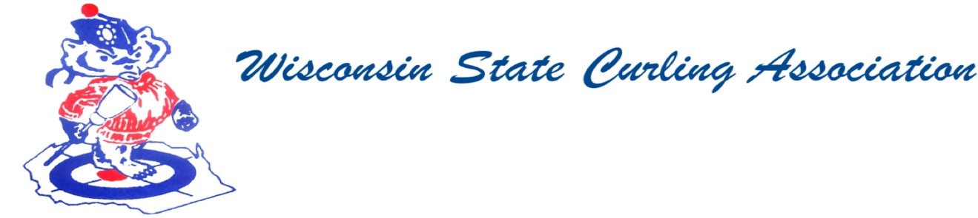
PRESIDENT  Dan Lilla  (608) 484-0509  lillaroad@aol.com  VICE PRESIDENT  Terri Gleason  (608) 575-0457  mntgleason@gmail.com  VP - PLAYDOWNS  Irv Mossberger Jr.  (218) 260-7458  imossberger@barr.com  SECRETARY  Vietta Kampen  (608) 697-6510  vkkampen@gmail.com  TREASURER  Greg Dunlop  (414) 708-5683  gdunlop1@hotmail.com  PAST PRESIDENT  Sam Johnson  (715) 559-1950  sam@curlingclub.com  USCA DIRECTOR  Terri Gleason  (608) 575-0457  mntgleason@gmail.com | Wisconsin State Curling Association Members Meeting  Saturday, May 14, 2022 at 9:30 AM  Zoom Meeting  https://jamf.zoom.us/j/91778782781?pwd=SVI4STFTUUViSWVrN0dIMGdVTHJTUT09  Meeting ID: 917 7878 2781  Passcode: 159577  Minutes  1) Meeting was called to order at 9:30 AM  2) Roll Call (Kampen)  - Present: Alpine, Appleton, Centerville, Eau Claire, Green Bay, Kettle Moraine, La Crosse, Madison, Medford, Milwaukee, Pardeeville, Portage, Racine, Rice Lake, Stevens Point, Superior, Wausau, Wauwatosa  - Absent: Arlington, Blackhawk, Clintonville, Loch Wissota, Lodi, Marshfield, Poynette, Tri-City, Waupaca,  - Guests: Mark Olson, Garret Perry, Sam Johnson, Jim Wendling, Mark Swandby, Kim Susens, Mason Tikkanen, Aaron Berstch.  3) Approval of WSCA Membership Meeting Minutes: Spring 2022 Terri Gleason moved  to approve the minutes. 2nd – Chris Horak. Motion passed.  4) President’s Remarks - None  5) Club Reports – See below  6) Old Business - None  7) New Business - None  8) Adjourn David Russell moved to adjourn. 2nd Doug Anderson Meeting was adjourned  at 10:06  Appleton Curling Club 2021-22 report:  1) we made it through COVID with minimal restrictions  2) Membership - down slightly, back to 2018-2019 levels  3) able to hold all the events (bonspiels, Learn to Curl) that we had originally planned on holding.  4) one member who began the year with us passed away from COVID  Thanks,  Todd Good  Blackhawk Curling Club, Janesville WI  After a year of voluntarily shutdown due to COVID, BCC opened back up in October 2021.  Our first Bonspiel was our traditional Women’s first Chance which filled at 16 teams and was a great start to our season. We followed it up with two additional sold-out Bonspiels (mixed January 2022, and Men’s March 2022)  Our membership was down approximately 10% from the 2019-20 season but our leagues remained strong.  Financially our club remains strong with zero debt and a comfortable balance of funds in our checkbook.  Plans are being made for a new Open style bonspiel tentatively scheduled for December 2022.  Respectfully submitted  Mark Olson  WSCA Spring 2022  Portage Curling Club  Portage didn’t curl during the 2020-2021 season, but we used the offseason to raise funds for an enclosed wheelchair ramp. In December, we held the US Open Wheelchair Bonspiel, hosting seven teams from around the US. The following week was our Men’s Bonspiel which was a huge success. In January we held our Junior Bonspiel, numbers were down, but the twelve teams had a great time. In February, twenty 5U teams competed for spots in the USA Curling 5U National Championships. Several teams qualified from this event that is starting this weekend.  We redid our mortgage in 2020. The new cooling tower was installed in September and the new insulation and siding will be going on this summer. Fundraising has continued. We raised funds for banners to honor all of our championship teams, applied for grants for new LED lighting in the icehouse, and are reaching our goal of raising $16,000 for a new camera, monitor, and broadcasting system.  Respectfully submitted,  Vietta Kampen

